Drupal Multisite Management Tools
Drupal has featured the ability to run multiple sites easily since Drupal 4.6. Drupal's Multisite features can help with the administration of any different sites a once, the grouping together of many related websites in one place, and saving Disk space by not having multiple copies of Drupal running from the same location. Different third-party tools exist to make multisite easier to manage. These tools perform differently based on what needs to be done. Drupal's multisite powers can be useful to create infinitely many Drupal-powered websites from the same code base and can be configured using different tools, such as Druplet, Hostmaster2, and the Multisite Manager Module.
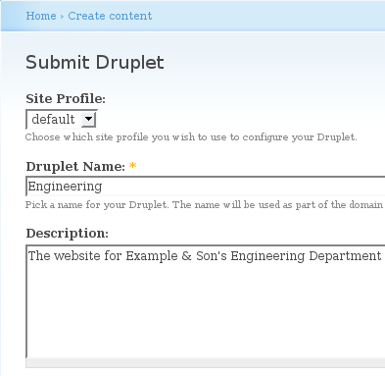
Installation Profiles, introduced in Drupal 5.0, are the basis for many multisite managers. Installation Profiles do not manage installations, they simply precustomize the site as part of the installation process. Installation Profiles are somewhat hard to create for those that prefer not to program anything. Installation Profile generators have been created that allow one to generate an installation profile based off of an existing site. These generators, for the most part, work extremely well, and only require hand tweaking for the more complected setups. Druplet is one such manager that takes advantage of Installation Profiles.
Druplet is a Multisite Manager that works pretty well for simple site creation. It has not yet seen a stable release, and requires checkout from the CVS repository. However, it seems very stable and will probably be released soon. Currently, it is not computable with Drupal 6. It is relatively easy to setup, as the hardest part is to create the installation profile that it will use. The use of Installation Profiles allows it to be extremely flexible with the creation of sites. The author of Druplet does recommend that it not be used in a production environment, as it may allow users to read the settings.php file from another site. For more information on Druplet, see http://drupal.org/project/druplet.
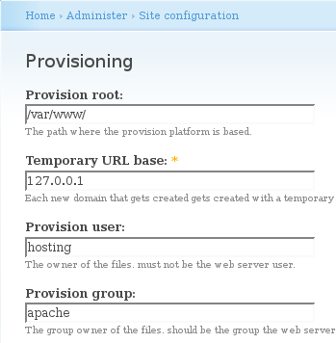
Hostmaster2 is yet another Drupal Multisite Manager. It is a little more complected than Druplet, and thus is somewhat hard to learn. Once past the ins process, Hostmaster2 is the most powerful way to manage Drupal sites. Installation of Hostmaster2 is difficult because it requires checkout of the correct things from Subversion. Many different things related to Hostmaster2 are still under heavy development, and the modules do not always work correctly. However, Hostmaster2 is wonderful when it works. Like Druplet, it uses Installation Profiles to precustomize a site as part of the site creation process. For more information on Hostmaster2, see http://groups.drupal.org/hm2 and https://svn.bryght.com/hostmaster.
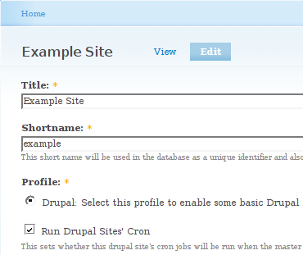
The Multisite Manager module is also similar to Druplet, but without the security problems. The current stable release is not compatible with Drupal 6. Using the Multisite Manager module is extremely easy, as it uses the standard Create content Song & Dance. Installation Profiles allow it to do further customization to the site while it is being created. The Multisite Manager module is an easy way to manage multiple sites, but it is not as powerful as Druplet and Hostmaster2. The Multisite Manager module is available at http://drupal.org/project/multisite_manager.
Drupal's Multisite capabilities can help make the running of many different sites easier using tools such as Druplet, Hostmaster2, and the Multisite Manager module. When these tools work correctly, they can simplify the administration process substantially. The use of installation profiles allows these managers to further customize the output site. The Multisite Manager tool is easily the best choice when managing multiple Drupal-powered website.
 | Multisite Manager Module | Druplet | Hostmaster2
Ease of Installation | Beautiful | OK, after the CVS checkout | Extremely Difficult
Ease of Use | After Installation profile creation, very easy | After Installation profile creation, Beautiful | Hard to get working
Security | Secure, unless the option to create separate databases is enabled | Can have a security risk associated with Database creation | With provisioning, pretty secure
Flexibility | Very Flexible | Very Flexible | Very Flexible
Ease of Upgrade | Not available for Drupal 6 | Not available for Drupal 6 | Not available for Drupal 6
Development | Stable development | Still in development, very stable | Still in development, not very stable

http://drupal.org/node/180078
As of 1/5/2008
In the default configuration; There is an option that will cause the Multisite Manager module to have the same problems as Druplet for the same reasons.
As of 1/10/2008

