Documentation of Next Previous Post Block module
Step 1:-
A. Go to the “Extend” link in admin menu.
B. Enable the “Next and previous link”. See the below screenshot.
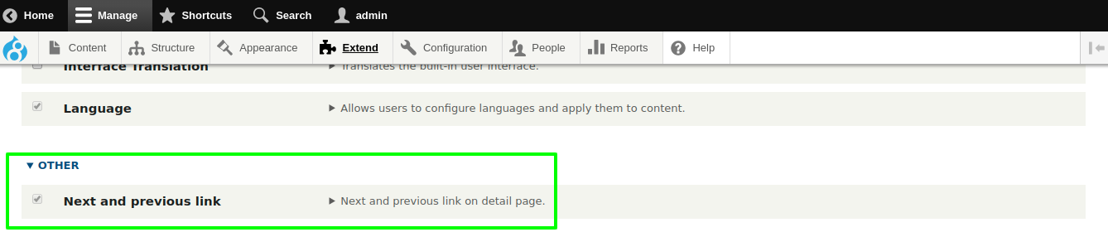
Step 2:-
A. Go to the “Block Layout”. Eg:- Admin Menu >> structure >> block layout
B. Go to the your block region.
C. Click the "Place block" button and in the modal dialog click the "Place block" button next to "Next Previous Block".
D. On the block configuration form you can choose the node bundle name to filter and the next/previous labels the buttons will have.
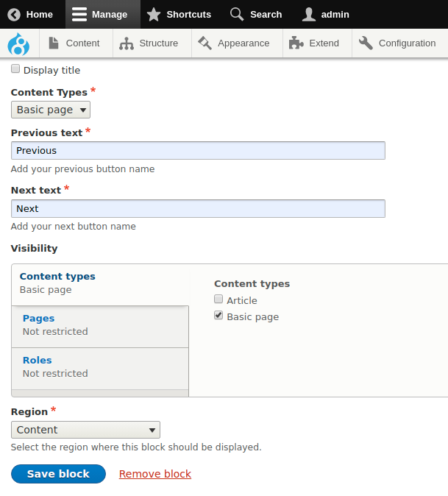
Step 3:-
A. Go to the detail page and you will Previous and Next link. See the below screenshot.


